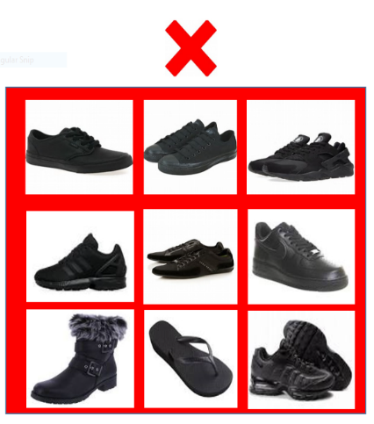
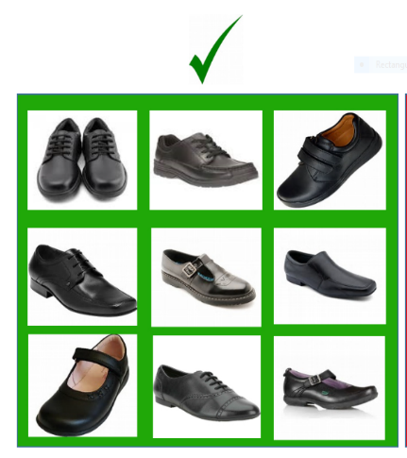
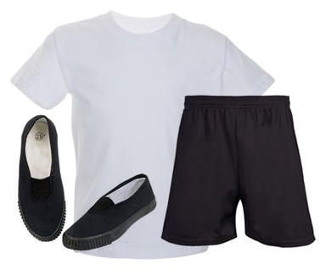
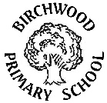
Birchwood Primary School uniform
For P.E children bring a change of clothes that they change into at dinnertime. The children go home in their P.E kit.
Children should wear:
- A plain white t-shirt
- Plain black shorts or black jogging bottoms
- Plain sweatshirts or tracksuit tops in colder weather
- Plain black or white trainers for outside, pumps for inside
If your child has earrings, these need to be removed for P.E sessions or covered with plasters from home. This is to prevent accidents during lessons.

Acceptable footwear guidance:
Acceptable – Plain black smart shoes of suitable design that protect against weather and spillages.
Unacceptable – Styles that offer little protection, canvas or trainer style or are not plain black are not suitable as part of the Birchwood school uniform.
Our Uniform shows that our children belong to our school community. Looking smart also supports a positive learning behaviour.
Children should wear:
- A plain white polo shirt
- Plain black trousers or black skirt
- A blue school jumper or cardigan with the school logo (these can be purchased through the school uniform shop on our website)
- Plain white/black socks or black tights
- Black school shoes
- In warmer months, children may wear black tailored shorts or a blue gingham dress
- If your child has their ears pierced they should only wear small silver or gold studs
- Long hair is tied back with a plain blue or black hairband

We believe children should wear uniform in school. We would like children to have pride in being part of Birchwood Primary School and in maintaining a well- dressed and smart appearance. Our school uniform has been designed so that much of it is easily accessible from large supermarkets.

