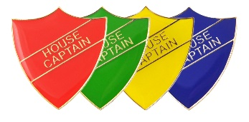

My Logo Design

Name:_____________________

Class: _____________________

House: Chaytor/Chetwynd/Morris/Goodere