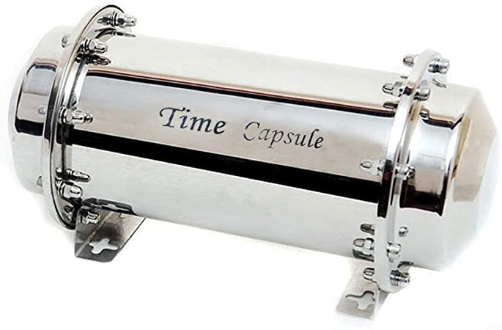
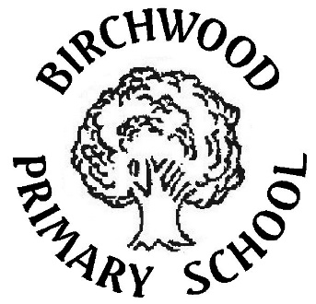
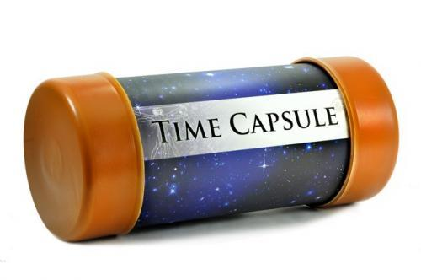
Birchwood’s Easter Home Learning Project
We are living through History right now!
Create a time capsule to look back on one day.
Here are some ideas of things to include:
- Write a letter to your future self.
Explain who your friends are, your favourite television shows, songs, games and books etc.
Write about what is going on in your own world and tell your future self how you feel about it all.
Explain what you want to do when you grow up and some of the things you would like to do when you are an adult.

- Draw a picture of your family.

- If it is safe to do so get a newspaper and include articles you think would be important for your future self. Or you could print them from online.

- Take some photographs of today to print out and include.
https://www.dropbox.com/s/po5rmhnau24vcg4/2020%20Covid-19%20time%20capsule%20sheets.pdf?dl=0
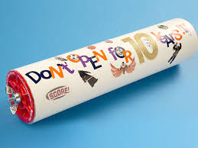
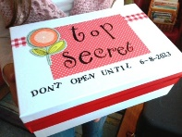
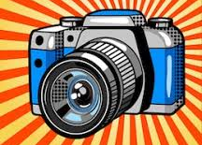
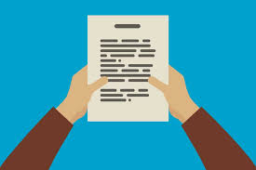
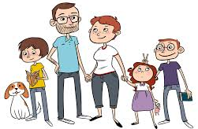

Put it all together in a scrap book or an old lunch box and hide it up in the attic or somewhere you will be able to find it in years to come.

