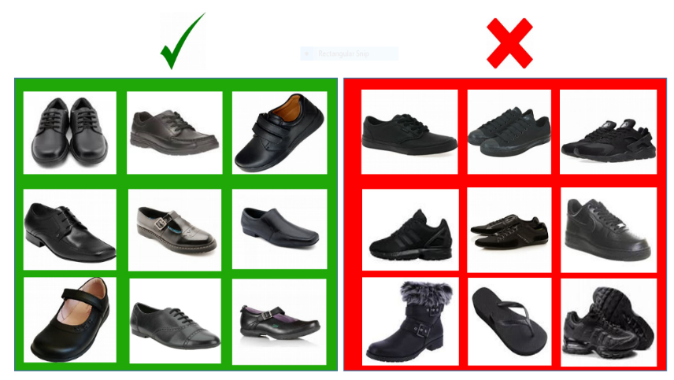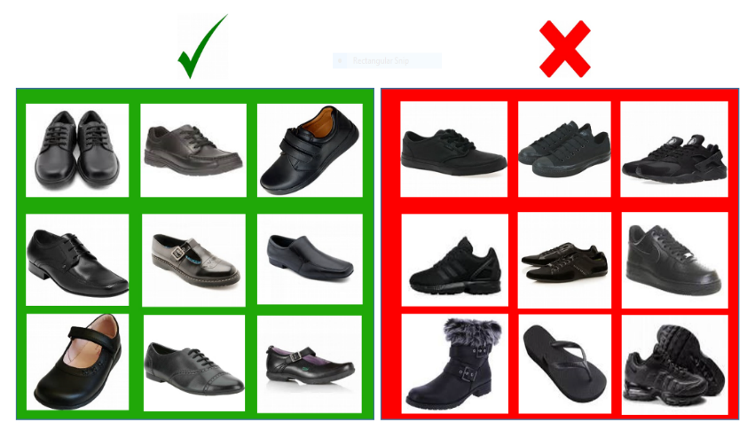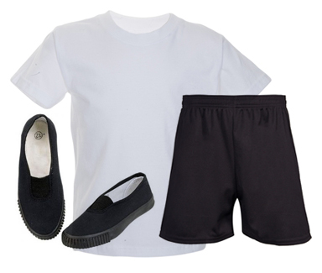**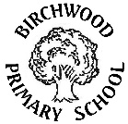Birchwood Primary School uniform**

**For P.E children bring a change of clothes that they change into at dinnertime. The children go home in their P.E kit.**

**Children should wear:**

* **A plain white t-shirt**
* **Plain black shorts or black jogging bottoms**
* **Plain sweatshirts or tracksuit tops in colder weather**
* **Plain black or white trainers for outside, pumps for inside**

**If your child has earrings, these need to be removed for P.E sessions or covered with plasters from home. This is to prevent accidents during lessons.**

**Acceptable footwear guidance:**

**Acceptable – Plain black smart shoes of suitable design that protect against weather and spillages.**

**Unacceptable – Styles that offer little protection, canvas or trainer style or are not plain black are not suitable as part of the Birchwood school uniform.**

**Our Uniform shows that our children belong to our school community. Looking smart also supports a positive learning behaviour.**

**Children should wear:**

* **A plain white polo shirt**
* **Plain black trousers or black skirt**
* **A blue school jumper or cardigan with the school logo (these can be purchased through the school uniform shop on our website)**
* **Plain white/black socks or black tights**
* **Black school shoes**
* **In warmer months, children may wear black tailored shorts or a blue gingham dress**
* **If your child has their ears pierced they should only wear small silver or gold studs**
* **Long hair is tied back with a plain blue or black hairband**

**We believe children should wear uniform in school. We would like children to have pride in being part of Birchwood Primary School and in maintaining a well- dressed and smart appearance. Our school uniform has been designed so that much of it is easily accessible from large supermarkets.**